Special Thanks

Alpha Chi Pledge
“I pledge myself to uphold the purposes of Alpha Chi, striving to make its ideals my ideals in scholarship and service.”

Alpha Chi Motto
“You shall know the truth and the truth shall make you free.”

Reminders

Alpha Chi
National College Honor Scholarship Society

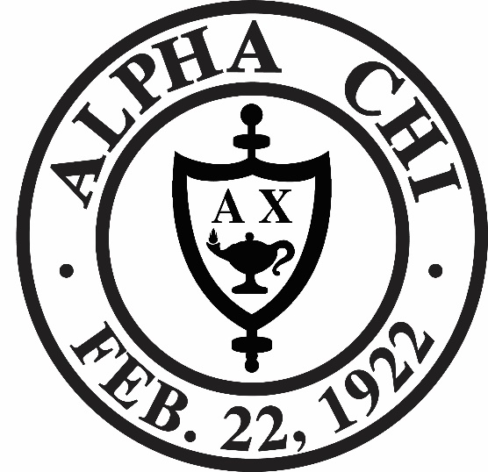

October 15, 2013
Induction Ceremony
Arkansas Eta Chapter
Harding University
Welcome
Greetings from Dr. Thompson
Introduction of Speaker
Guest Speaker, Dr. Larry Long
University Provost
“Honor and Service”
Induction Ceremony
Comments from Dr. Linda Thompson
Reception
~~~~~~~~~~~~
Arkansas Eta Chapter Sponsors
Dr. Linda Thompson
Dr. Travis Thompson
Dr. Sarah Wilhoit
Chapter Officers, 2019-20
President Marissa Williams
Vice President Ty Felton
Secretary-Treasurer Catherine Morrow
Historian Micah Day

Inductees, 2019-20
Last, First
Last, First
Last, First

